Name: RIZWAN
Roll No:22
Batch: MCA -B
Date:25-04-2022

NETWORKING & SYSTEM ADMINISTRATION LAB

Experiment No.: 8

Aim
Familarization of linux commands

Procedure
- useradd
useradd is a command in Linux that is used to add user accounts to your system
Output
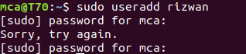

- passwd
passwd command in Linux is used to change the user account passwords. The root user reserves the privilege to change the password for any user on the system, while a normal user can only change the account password for his or her own account.
Syntax:
passwd [options] [username]
Output
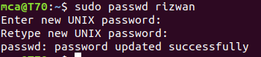

3. groupadd
groupadd command is used to create a new user group.
Syntax:
groupadd [option] group_name

Output
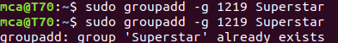

4.usermod
usermod command or modify user is a command in Linux that is used to change the properties of a user in Linux through the command line
Output
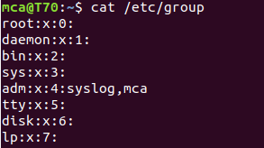

5. compgen
compgen is a bash built-in command which is used to list all the commands that could be executed in the Linux system. This command could also be used to count the total number of commands present in the terminal or even to look for a command with the specific keyword.
Output
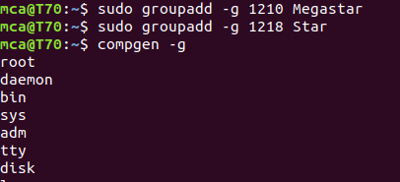

6. userdel
userdel command in Linux system is used to delete a user account and related files. This command basically modifies the system account files, deleting all the entries which refer to the username LOGIN. It is a low-level utility for removing the users.
Output
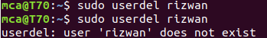

7.groupdel
groupdel command is used to delete a existing group. It will delete all entry that refers to the group, modifies the system account files, and it is handled by superuser or root user.
Output
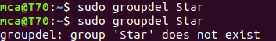

8.chmod
the chmod command is used to change the access mode of a file.
The name is an abbreviation of change mode.
Output
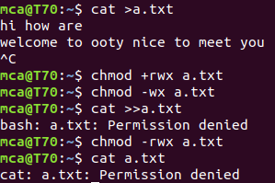

9 chown
chown command is used to change the file Owner or group. Whenever you want to change ownership you can use chown command.
Output

